# Purpose

This reference document describes how to deploy ESR 44591 - ECN1078377L re-number.........Yet another problem with the new ECR/ECN process.

# Revision History

Document revision history is controlled by [http://windchill.carrier.utc.com](http://windchill.carrier.utc.com/) (UTC BIS Production Server).

<http://windchill.carrier.utc.com/Windchill/app/#ptc1/tcomp/infoPage?oid=VR%3Awt.doc.WTDocument%3A2439560183>

# Change History

| Date | Revision | Technician | Description of change and a link to affected section |
| --- | --- | --- | --- |
| 28th Aug 2015 | -.1 | Anubha | ECN1078377L re-number.........Yet another problem with the new ECR/ECN process. |

# Issue/Change Summary

Enable Members Role to edit the ECN number and add/remove attachments for CECM ECN in Commercial Engineering Change Processes container.

# Deployment Status

Below table contains current status of these changes, this tables will be updated by Infrastructure Team

|  |  |  |  |  |
| --- | --- | --- | --- | --- |
| **Servers** | **Local Machine** | **Development** | **Staging** | **Production** |
| **Deployed by** | Anubha | Rijoy |  | Fayaz |
| **Deployed Date** | 28th Aug 2015 | 28th Aug 2015 |  | 16th Sep. 2015 |
| **Validated by** | Anubha |  |  | Kayle |
| **Validated date** | 28th Aug 2015 |  |  | 16th Sep. 2015 |

# Check List

Below are the lists of items that need to be verified before scheduling deployment on test and production server.

|  |  |  |  |
| --- | --- | --- | --- |
| **Check-list** | **Rehearsal** | **Pre-Production** | **Production** |
| **Files updated to SVN** |  |  |  |
| **Included manual recovery steps** |  |  |  |
| **Included validation Steps** |  |  |  |
| **Validation Confirmation from User** |  |  |  |
| **Database Export required** |  |  |  |
| **LDAP Export required?** |  |  |  |
| **Windchill codebase Backup?** |  |  |  |
| **Selected Files Backup** |  |  |  |
| **Change Control Required?** |  |  |  |
| **Windchill Start/Stop required?** |  |  |  |

# Enhancements / Resolution

Below are the different steps involved during deployment.

## Specify the SVN Location

[WC DEV](http://cusnwa5d.carrier.utc.com/wc/wcsvn/branch/WCDEV/loadFiles/ext/carrier/wc/acls)

## List of all OOTB & Custom files modified to resolve this issue

Below are the lists of files that are modified to resolve this ESR.

|  |
| --- |
| **File Name** |
| **NA** |

## List of all OOTB and Custom files added to resolve this issue

Below are the lists of files that are added to resolve this ESR.

|  |
| --- |
| **File Name** |
| **<!--ACLs-->**  /apps/ptc/Windchill/loadFiles/ext/carrier/wc/acls/CECM_Grant_ModifyIdentity_Content.xml – This file need to to updated |

## Backup Procedure

1. **Partial Backup**

If we need to take backup of selected files from windchill codebase list them in below table

|  |
| --- |
|  |

1. **Full Backup**

This involves Windchill codebase, database and LDAP backup. In order to back and restore refer to Windchill re-host/Cloning process.

## Manual changes before deploying changes

NA

## Actual Deployment procedure

1. Copy the above listed file to its specified location.
2. Go to Windchill shell and run the below command:

windchill wt.load.LoadFromFile -d /apps/ptc/Windchill/loadFiles/ext/carrier/wc/acls/CECM_Grant_ModifyIdentity_Content.xml -u windchill.wcadmin@carrier.utc.com -p admin123 -CONT_PATH \"/wt.inf.container.OrgContainer=Carrier/wt.pdmlink.PDMLinkProduct=Commercial Engineering Change Processes\"

## Post Deployment steps

NA

# Validation

Login as a non-administrative user who is mapped to Members role in **Commercial Engineering Change Processes** container and verify the following:

1. Click on Create New Change Notice icon and verify if the window has **Set Attachments** tab:

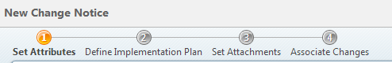

2. Create CECM Change Notice using the following values:

**Product Family:** 09D

**Category:** Obsolescence

**Reason for Change:** Quality Improvement

**Plants Affected:** CLT

3. Click on next and ensure that you are able to add attachments to the ECN.

4. After the ECN is created, go to the ECN details page. From the Actions menu, go to Edit and check if **Set Attachments** tab is still available and that you are able to add/remove attachments.

5. Next, from the Actions menu, go to Rename and check if you are allowed to edit the ECN Number:

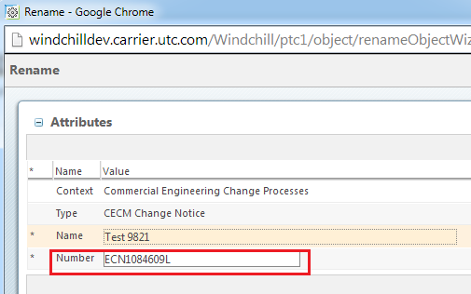

# Steps to Restore (On Failure/if Needed)

* + Go to **Commercial Engineering Change Processes** -> Utilities -> Policy Administrator and delete this ACL:

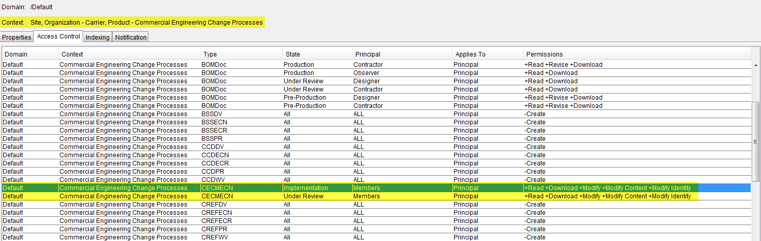

# Issues encounter during deployments (If any)

Below are the known issues which are observed in the Carrier WC systems results in failure of the load

# Manual Installation Procedure

In this section list manual steps required in case if build failed

# Contacts

Details of all the contacts who are involved in different phases of deployments will be listed over here.